Cairo University  
Faculty of Computers and Information



**CS251**

**Software Engineering I**

Masroo2a

Software Design Specifications

Cool Beans

December 2018

Contents

Team 3

Document Purpose and Audience 3

System Models 4

I. Class diagrams 4

II. Sequence diagrams 6

Class - Sequence Usage Table……………………………………………………………………………………………………………….9

Ownership Report 10

References 10

Authors 10

# Team

|  |  |  |  |
| --- | --- | --- | --- |
| **ID** | **Name** | **Email** | **Mobile** |
| 20160291 | Youssef Ahmed Hassan | androidlooney@gmail.com | 01126890691 |
| 20150180 | Amr Anwar Mohamed | amrtop2000@gmail.com | 01144100945 |
| 20160292 | Youssef Ahmed Ali | youssefelhefnawy@gmail.com | 01093292180 |

# Document Purpose and Audience

* **This document is a brief overview on “Masroo2a”.**
* **This document is intended to be read by the stakeholders.**

# 

# System Models

## Class diagram

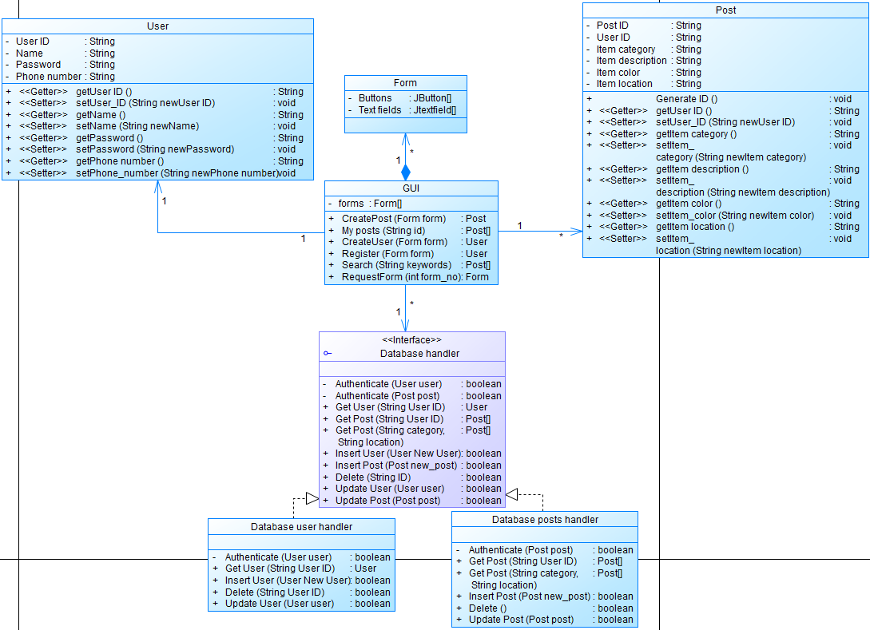

| **Class ID** | **Class Name** | **Description & Responsibility** |
| --- | --- | --- |
| User ID | User | A user has a name, password and phone number. They can log in to the application using their name and password, post about their lost item, post a found item or search on items matching the search keywords. They mustn’t post fake posts and it’s their responsibility to return the lost item. |
| Post ID | Post | A post has a category, a detailed description, optionally a color and the location where it was lost/found. Most importantly, each post contains the ID of the user who posted it. |
| N/A | Database handler | The database handler returns posts based on their post IDs or other post attributes. It can delete a post or authenticate a new post before storing it in the database. The database handler should remove any post that doesn’t get resolved for over 2 months. |
| N/A | GUI | The GUI is the interface that the user deals with. It has a list of forms each of which have a list of text fields and buttons. The GUI can create an instance of post, create an instance of user, let the user register or search or view posts. |

## 

## II. Sequence diagram

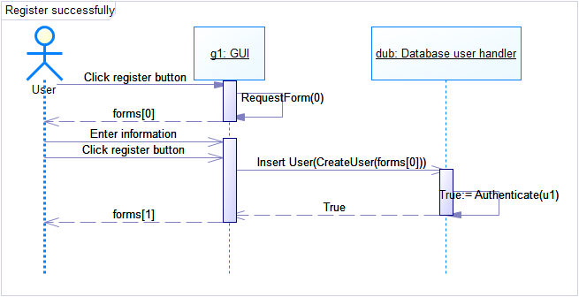

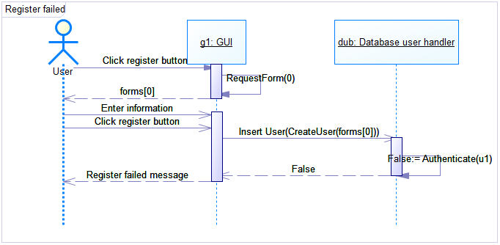

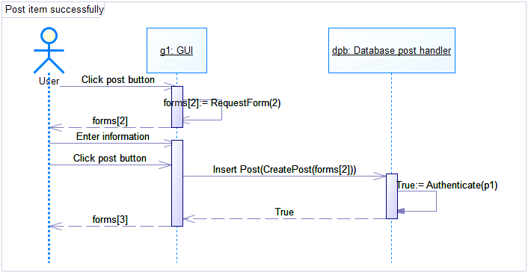

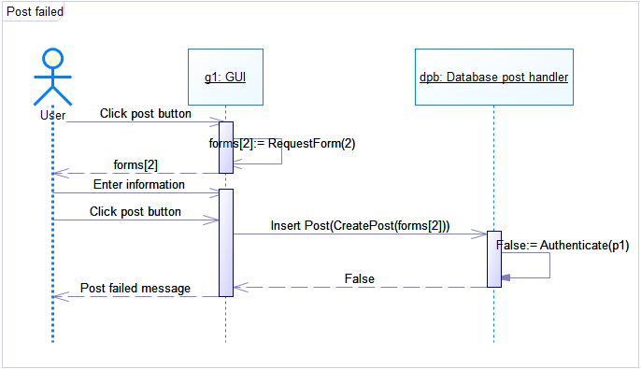

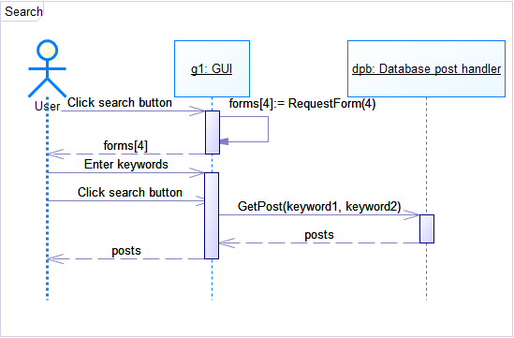

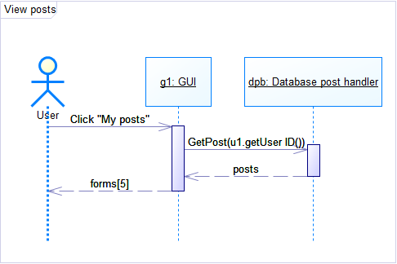

| **Class Name** | **Sequence Diagrams** | **Overall used methods** |
| --- | --- | --- |
| User | 1, 2, 3, 4, 6 | Setters and Getters |
| Post | 3, 4, 5, 6 | Setters and Getters |
| GUI | 1, 2, 3, 4, 5, 6 | RequestForm |
| Form | 1, 2, 3, 4, 5, 6 |  |
| Database handler | 1, 2, 3, 4, 5, 6 |  |
| Database user handler | 1, 2 | Insert User and Authenticate |
| Database post handler | 3, 4, 5, 6 |  |

# 

# Ownership Report

|  |  |
| --- | --- |
| **Item** | **Owners** |
| Class diagram | Youssef Ahmed Ali & Amr Anwar |
| Sequence diagram | Youssef Ahmed Hassan |

# References

* http://www.mhhe.com/engcs/compsci/pressman/graphics/Pressman5sepa/common/cs1/design.pdf

# Authors

* Mostafa Saad and Mohammad El-Ramly (Edited by Mohamed Samir)